To: Mike Carroll Date: 29 May 2003

From: Tom De Vries

Subject: KCAT Verification Transition Matrix

I thought it would be interesting to check on the accuracy of the Verification problem transition matrix calculation, comparing the matrix exponential method with the exact analytical form. For the second order system that your specified, the analytical matrix can be found quite easily, as follows.

First write the differential equations in Laplace form, considering only initial condition on the states:

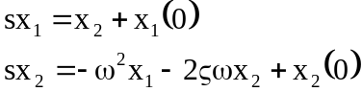 (1)

This can be written in matrix form as

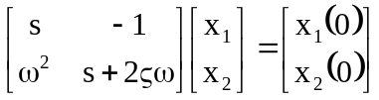 (2)

Solving for the initial conditions then gives

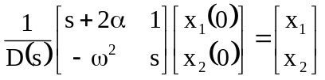 (3)

where the characteristic polynomial is

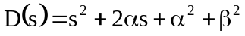 (4)

and
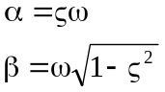

The transition matrix 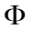 is then the inverse Laplace transform of the coefficient matrix on the x(0) vector. The elements of 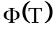 are:
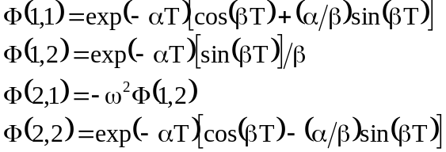 (5)

When the values

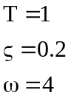

are substituted into Eq. (5), the following values are obtained:

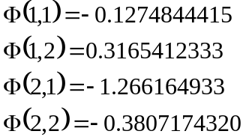

These values check exactly (to 10 places) with the transition matrix computed with a 15 term matrix exponential and a 0.1 sec step, raised to the 10th power:



